Exercise 3:

English do exercise 3 (pair work) on the Photocopy "G a revival through jazz" (do in between 5 and 10 questions in the globality)

1. 1: Journalist: So, what where you’re feelings about this cyclone?
2. Singer: The cyclone was terrifying, but the worst was what happened to my belongings, I only have my ~~good~~ old faithful instrument and my clothes. Nothing else.
3. 2: Journalist: and how did you survive with just your clothes, and you’re instrument? How did you cope emotionally ~~survive~~?
4. Singer: At first it was very difficult because I had to start from zero ~~nothing~~. I didn’t know where my family was, I had no money, no phone, I only had my hands and my instruments with my voice to earn money, or at least express my feelings about the natural disaster that had struck us.
5. 3: Journalist: What kind of music did you sing?
6. Singer: I would play a knew fashion that ~~had been~~ was created after the disaster, it was called the new jazz revival.
7. 4: Journalist: That must have been a very helpful form of jazz, but please tell me more about the way you sung your music? We’re you singing on your own or with a Jazz band?
8. Singer: I was with other singer’s that emotionally had difficulties overcoming their emotions and so together we would write and play songs.
9. 5: Journalist: Did you play your music on stage or just for yourself?
10. Singer: My group and I would play on stage and sometimes improvise ~~k~~new tracks in live.
11. 6: Journalist: Did you record any of your music’s at the time?
12. Singer: unfortunately, we didn’t because we didn’t have the necessary equipment to. So, what you can hear nowadays has been recorded much later when we were much older.
13. 7: Journalist: did the music help you in the harder moments like when you had to rebuild your life?
14. Singer: yes, but what would happen was that some days we would play for everybody. On ~~and~~ other days it would be another band that would take our place like Lu Watters or Sid Le Protti's Barbary Coast or even The Turk Murphy Jazz Band.
15. 8: Journalist: Wow ~~these~~ those are some bands. I listened to a few of the myself. How long did it take you to recover from your emotional state after this hurricane?
16. Singer: I never totally recovered from this event. Even if we are used to having cyclone that destroy everything, we’ve never experience something, that strong and devastating.
17. 9 Journalist: Do you still play revival jazz nowadays?
18. Singer: yes, I do and it’s how I still earn my living.
19. 10 Journalist: do you still compose music nowadays?
20. No unfortunately I don’t.
21. Journalist: Well it was nice meeting you and hope to see you soon.
22. Singer: I hope so to. Goodbye
23. Journalist: Goodbye

Credits:

* <https://www.theguardian.com/music/2018/jun/16/kamasi-washington-interview-jazz-is-like-a-horse-you-can-ride-out-on-heaven-and-earth>
* <https://www.musicmusingsandsuch.com/musicmusingsandsuch/2018/8/8/feature-re-birth-of-the-cool-is-the-jazz-revival-here-to-stay>
* <https://www.youtube.com/watch?v=iuFNtGqel0I>
* <https://en.wikipedia.org/wiki/Terry_Waldo#Career>

an ordeal / a hardship = une situation difficile

exposé anglaise:



<https://www.irishcentral.com/opinion/cahirodoherty/australian-governments-anti-immigrant-poster-shocks-planet-video>

<https://bit.ly/2lVS9YP>

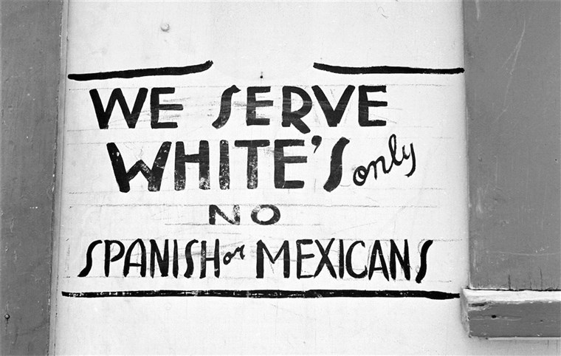

<https://bit.ly/2kkaajl> (site ayant l’image), <https://media4.s-nbcnews.com/j/newscms/2019_33/2023466/170602-russell-lee-segregation-ac-506p_6e00acc731f13c9216ae0a169e65a54e.fit-2000w.jpg> (l’image)

<https://bit.ly/2lNDZcu>

<https://www.youtube.com/watch?v=OIT0ucf_gys>

lyrics land of the free :

Oh oh oh oh, oh oh oh oh  
I'm standing crying (oh oh oh oh)  
I'm standing crying (oh oh oh oh)  
So how many daughters, tell me, how many sons  
Do we have to have to put in the ground  
Before we just break down and face it  
We got a problem with guns? (Oh oh oh oh)  
In the land of the free  
Down at the border, they're gonna put up a wall  
Concrete and Rebar Steel beams (I'm standing crying)  
High enough to keep all those filthy hands off  
Of our hopes and our dreams (I'm standing crying)  
People who just want the same things we do  
In the land of the free

Land of the free, land of the free  
In the land of the free  
Land of the free, land of the free  
Land of the free, land of the free  
In the land of the free  
Land of the free, land of the free  
Land of the free, land of the free  
Land of the free, land of the free  
In the land of the free (I'm standing crying)

We thought It would be interesting to compare this sign with a song against the construction of the wall on the Mexican-American border. First, it's important to explain the context. The construction of this wall was started after the end of the Mexican-American war, in 1848. The outcome is that Mexico loses around 50 percent of territory which is now California and Texas. Initially on the new border there is no wall, it is just marked at regular intervals by a pile of stones, its aim was to represent the imaginary wall. People could move freely. Then, 4 years later, in 1891, these piles of stones were replaced by white pillars As the US decide to map the border more accurately. At this point the wall was still imaginary. Then in 1897 in many places the US demolish buildings etc and impose there be a wide strip of no man’s land on either side of the border so that visibility is better to spot smuggling which is on the rise of everyday items to avoid import tax.

What is interesting is that through the history of the wall there have been many iterations and their purpose varied: So, let me take you to the early 1900s where this time it is actually the cattle the US want to control as ticks are spreading disease, what can stop it? A simple fence of course. This is then followed by a bigger fence which this time is to control immigration (Chinese, then Mexican, then German spies in the first WW). In 1918 saw big wire fence being built. But its aim was mostly to diffuse tension than stop people from crossing. The big change comes in 1940s as many Mexican immigrant’s cross to the US to work on the farms which is follow many illegal immigrants crossing to the US to look for work. The wall becomes a barbed wired metal fence in but in the 1990s These metal fences are made solid by reusing the metal landing helicopter mats from the Vietnam War.

On September 11th, 2001 the Twin Towers are hit leading to further tightening of immigration rules and the length of the wall expanded by five times. The harder it is to enter the US the more people are attempting to enter illegally. In turn this leads to more reinforcements of the borders and hence the wall.

More recently, a project suggested by Donald Trump has been to replace the walls made from the Vietnam War mats by much higher concrete coloured walls. Trump's proposal has been met with a lot of opposition and protest including films, works of art and also songs: so we chose the song “Land of the free” because it illustrates the horror, the violence, the reason for the construction of the wall. This music expresses the opinion of many Americans, Mexicans, strangers that think it is immoral to build a wall to stop humans from crossing borders. We think that even if they try to customise the wall it’s still a concrete wall it does not change what fundamentally the wall does. There have been many peaceful ways of expressing disapproval and this has also been done through music. If we take a look at the words of the song “Land of the free” we can notice that the song names America as “the land of free” and that the person that is not named but used in the song is a migrant that succeeded in his aim of crossing the border to get to America. If you listen to the words, you can notice that “I’m standing crying”, “Oh oh oh, oh oh oh” and “land of the free” appear quite frequently (every paragraph), meaning that the other people mentioned in the song are envying America and are desperate to join the other side of the wall. And this memory saddens the author who washes his truck in the Sinclair station, “Can’t wipe the wind-blow smile from across my face”. It upsets the author so much that he cries at the sight of the migrants, Mexicans trying to cross the border hoping for a better life.

Alternatively, other artists have tried to find ways to help people connect on both sides of the border wall. They didn’t necessarily break the law, or destroy the wall, but they tried to use the good sides of it to help separated families to make a connection. The wall isn’t only composed of Heli-mats there are also some places where there are vertical bars instead. The artists put a rectangular pink bar through the wall and so it balanced on either side creating a see-saw. This is just one of the many way’s artists have attempted to help families link.

Personal Opinion:

I think it is horrible to separate families, traumatic, to block people, to stop them from accessing freedom. I also think that what artists are doing to try and help families reunite even if a wall separates them is fantastic and should be maintained. Finally, I think that even if racism has been around for ever, it is essential to reduce it to a minimum or preferably end it for once and for all.

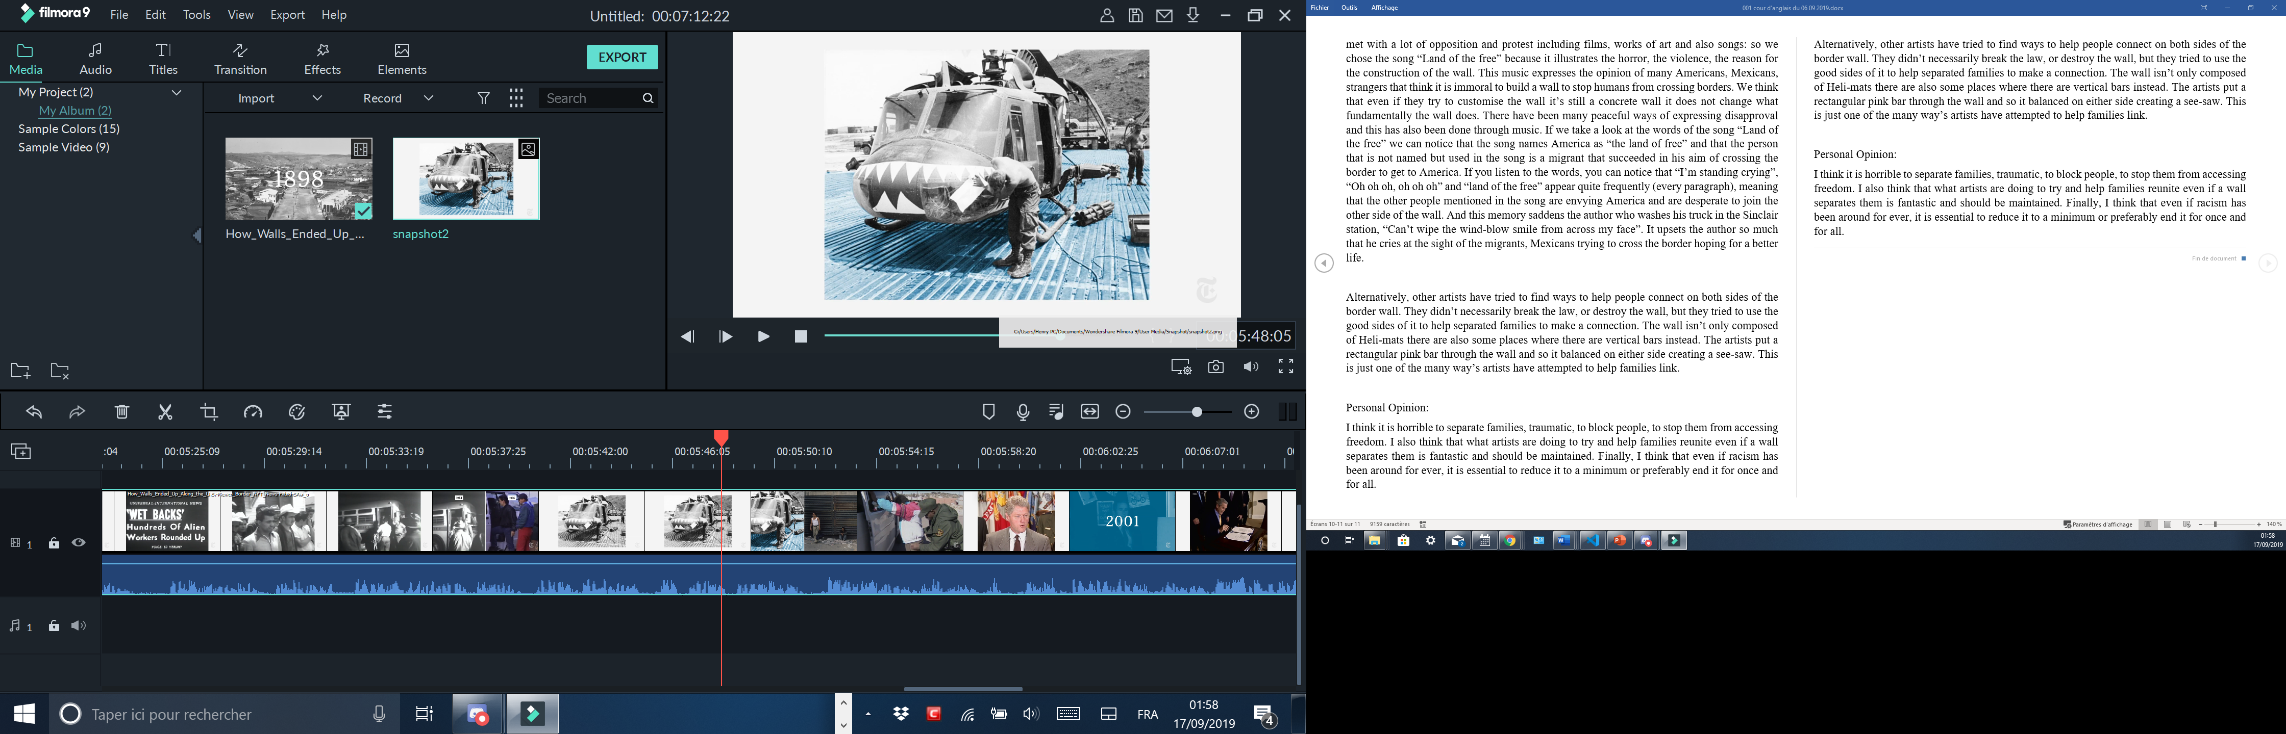

<https://img.20mn.fr/ndp7POGDSEqAc2due7L1cw/310x190_twin-towers-world-trade-center-11-septembre-2001.jpg>

  
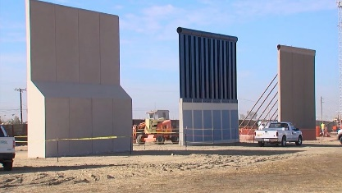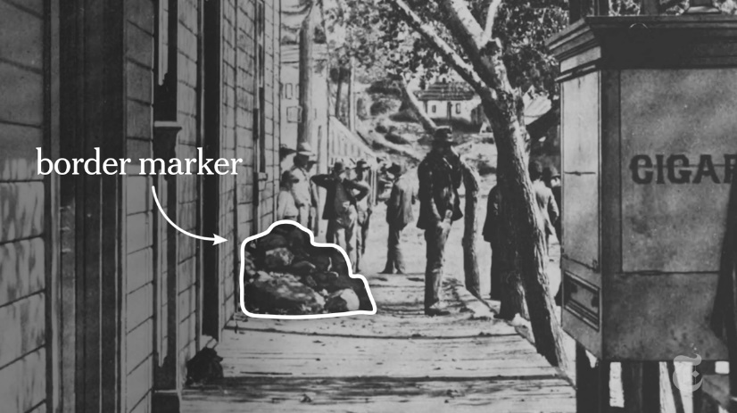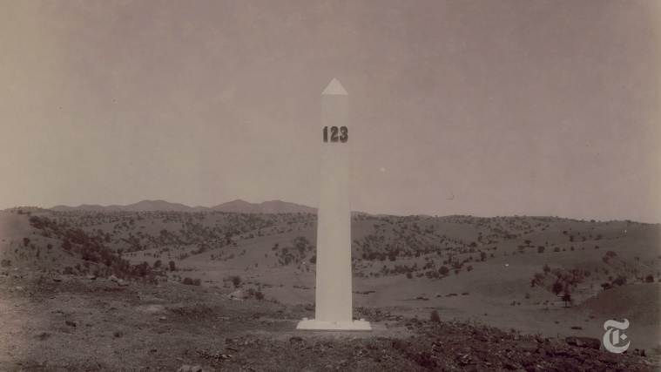

<https://www.google.com/url?sa=i&source=imgres&cd=&ved=2ahUKEwjo7t6pzdbkAhWdDWMBHcW0BjQQjRx6BAgBEAQ&url=https%3A%2F%2Fqz.com%2Fquartzy%2F1182972%2Ftrumps-border-wall-prototypes-are-art-argues-artist-christoph-buchel%2F&psig=AOvVaw0bodZZeKSQH-D7h18XxV1t&ust=1568766643456622>

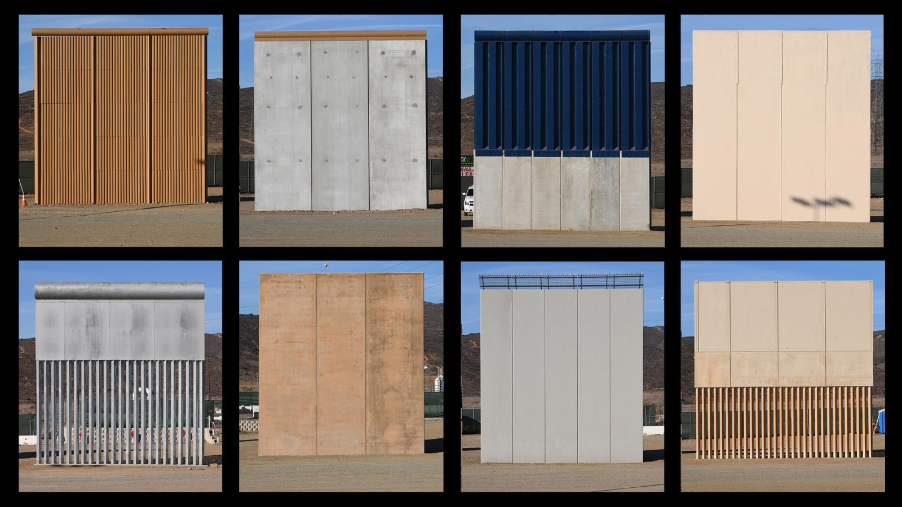

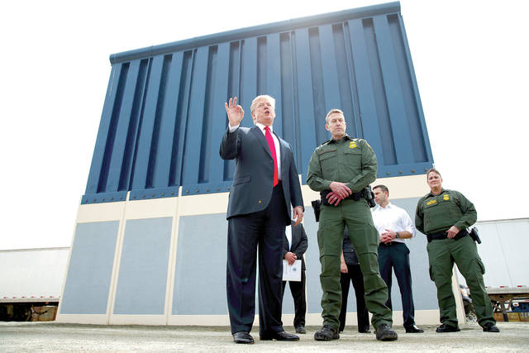

<https://www.hawaiitribune-herald.com/wp-content/uploads/2018/03/web1_AP18086723862996.jpg>

Friday, 27 September 2019

Voc:

A scrounger = a thief, a theft, a robber

A burglar = a thief who enters your house

A shareholder = stockholder

Impeachment = destitution.

To fire = to lay-off = to dismiss = to make people redundant

Touchy = sensitive

Ex 1 p 142: (Another way)

a)

My reaction is that I’m surprised to see the Statue of Liberty with its hand up, indicating a refusal of something or somebody. The position of the hand is such that it says ‘stop’ like a policeman controlling the traffic. The angle of the illustration makes you feel small, looking up at the statue.

b)

The message “Who gets to be an American?” is unusual because the Americans themselves are a nation of immigrants which seems incongruous with their history. The debate within the country is highly controversial and dividing the country – whereas before everybody who wanted to enter the US could and start a new life. They were pioneers starting in the 17th century.

2

a)

The line “the immigration debate that is dividing the nation” is the message on the Times cover, the poem Refugees expresses two opposing opinions depending on which direction you read the poem. It is written by Brian Bilston and I think he believes that immigrants should be helped in the U.S. First you read the poem and you feel it is unjust but once you read it the other way you realise how clever it is – it’s a powerful message and technique to express two opposing views.

b)

“[People around the world express more support for taking in refugees than immigrants](https://www.pewresearch.org/fact-tank/2019/08/09/people-around-the-world-express-more-support-for-taking-in-refugees-than-immigrants/)”

“[Growing share of Republicans say U.S. risks losing its identity if it is too open to foreigners](https://www.pewresearch.org/fact-tank/2019/07/17/growing-share-of-republicans-say-u-s-risks-losing-its-identity-if-it-is-too-open-to-foreigners/)”

“Refugee admissions into the U.S. have declined substantially during Donald Trump’s presidency.”

Trump and the Mexican wall

3

Neither of them because the poem has a two-way sense, in one way it is against immigration but in the other way it is for immigration. There are always two sides to an argument, two ways of viewing things.

Voc

To realise = se render conte

To make a dream come true = rendre un rêve réalité

Painstaking = hard-working

To be devoted to = être dévoué à

To endow = to receive

Boundaries = the border

Summary of the text: The pursuit of happiness

In the text Einstein say’s that the Americans aren’t dollar chasers, the students aren’t looking and bending over backwards to earn money. He says that they are good scientists even if some are better than other. He also say’s worship a god. That most of the people are calm and live a normal calm life. For Einstein, students link superpowers to the mind and character. This is what Einstein wanted. And that the previous descriptions (materialistic country) isn’t a true fact.

To look for = chercher

Unbearable = invivable

A pre-conceived idea = a stereotype, a cliché.

Summary of the text “born in the USA”:

In the text, the author mentions that he came to America hoping for a better life, He didn’t want to become an Austrian policeman like his father. So, he went to America and a tried to realise his “American dream”. To realise this dream, he was helped by very generous Americans that allowed him to go beyond his thoughts. He is for immigration nut thinks that if you want to integrate America, you must work and give something back. Then he gives a few steps of advice, like learning to speak English. He arrived at Hollywood in 1968 speaking a little bit of English and soon enough took speaking lessons to be able to progress n his job. The next piece of advice is to get involved in the politics of the country, learn about it, think, … He also says that not everybody is capable of being albert Einstein, but he quotes a martin Luther King Jr sentence ‘Anybody can be great, because anybody can serve”. The third advice is that you must continuously learn and be informed about democracy. The last advice that he gives us is to “give something back”, in other terms, serve the nation.

To pay a tribute to = être redevable

The common points between the two texts are that both of the characters want to enter the US. Both have had their own idea of the USA and once in there they discover that their idea is not completely true.

To buy at bulk

To lay off = to fire

An anthem

A retailer ≠ wholesaler

A stockholder

A melting pot = a land of immigration

Income = revenue

Premises= the place

To be on the premises = to be on the spot

Findings=results=outcomes

To result in (something) = résulter en

To generate = provoquer

A figure/ a number = un nombre

To figure out = trouver la solution

To work out/to setle = faire du sport

To deal with =

To handle =

Bold = audacieu, en gras

Survey findings = results = outcomes

A survey = an opinion poll

A shaft = un mat

Timber = building wood

To look forward to + verb in ing =

To hear from = prendre des Nouvelles

In a near future = dans un future proche

A = schéma

Articles:

If a noun is abstract life/war/nature/freedom/… there is no article.

Concerning the country:

A singular country has no article

A plural country has an article.

**Grammar:**

~~.~~

1) He lives in America 🡪 Present simple

In English, if you use for or since (depui) in English, you have to use the present perfect. You cant say : ~~He lives in America for two years~~, you must say:

How long +Present perfect

For + Present perfect

He has in America for 6 years 🡪 it’s still true

He lived in Russia for 5 months;6 years 🡪 Past simple + For =

To cluster = to gather

How to write a letter

From to

Ref subject x Date

Opening salutation (Dear Sir, Madam; Dear Mr James; Dear John)

Closing salutation (yours faithfully; yours sincerely; Best Regards)

A scholar = un savant

A wide spread = all over